**The laboratory work 3**

**Stored procedures**

A stored procedure is an SQL script that has parameters. It means that is executed as a usual procedure. Depending on values of a stored procedure’s parameters, we get some results of queries. In the SQL Server stored procedures realize dynamic queries executed on a server’s side. Let’s look on creation of a stored procedure using SQL commands.

Create a new SQL Script.



Create an example of a stored procedure to work with numbers

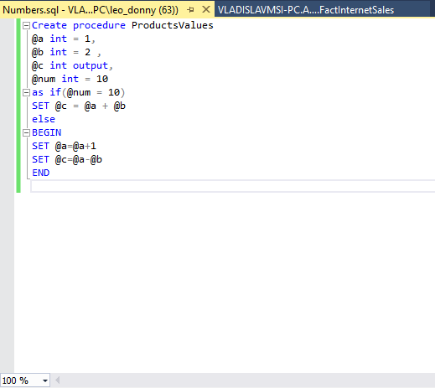

**Variants of exercises for students**:

1. Create a stored procedure that displays how many years have passed since 2000. Display a number of leap years since 1000. Choose a table in your database that has a column with numerical values. Display all rows where values in columns are smaller or equal to the input parameter.
2. Create a stored procedure that count an arithmetic mean of 5 numbers. Display how many centuries passed since 1500. Choose a table in your database that has a column with numerical values. Display all rows where values in columns are smaller or equal to the input parameter.
3. Create a stored procedure that count a geometric mean of 6 numbers. Find out whether an input date is in winter, spring, summer or fall. Use the following command: **SET DATEFORMAT**. Options of the date format have the following values: **mdy**, **dmy**, **ymd**, **myd** and **dym** (m, d and y are day, month and year accordingly). Choose a table in your database that has a column with numerical values. Display all rows where values are between two input parameters.
4. Create a stored procedure that displays your first name, last name and age. Write a stored procedure that will show what day of week is today. Choose a table in your database that has a column with numerical values. Display all rows where values are between two input parameters.
5. Create a stored procedure that compares three numbers and shows the greatest one, the smallest one and the middle one. You have 4 input parameters, and you need to find a value of an expression $F=a*4-6*b+7*c$. Choose a table in your database that has a column with numerical values. Display all rows where all values are bigger than three input parameters.
6. Create a stored procedure that finds the longest string of 3 input ones. You have 3 input parameters, and you need to find a value of an expression $F=2*a-5*c+2*d$. Choose a table in your database that has a column with numerical values. Display all rows where all values are bigger than four input parameters.
7. Create a stored procedure that finds the shortest string of 3 input ones. You have 4 input parameters, and you need to find a value of an expression $F=5*b-4*a*b-3*c-12*b$. Choose a table in your database that has a column with numerical values. Display all rows where all values are between two input parameters.
8. Create a stored procedure that count an arithmetic mean of 5 numbers. Choose a table in your database that has a column with numerical values. Display all rows where all values are between two input parameters. You have 3 input parameters, and you need to find a value of an expression $F=a-3*b+5*c$.
9. Create a stored procedure that displays how many years have passed since 1900. Display a number of leap years since 800. Choose a table in your database that has a column with numerical values. Display all rows where all values are bigger than two input parameters.
10. Create a stored procedure that finds the longest string of 5 input ones. You have 4 input parameters, and you need to find a value of an expression $F=5*a-3*b+2*c*d$. Choose a table in your database that has a column with numerical values. Display all rows where all values are between two input parameters.
11. Create a stored procedure that count an arithmetic mean of 6 numbers. Display how many centuries passed since 1700. Choose a table in your database that has a column with numerical values. Display all rows where all values are between two input parameters.
12. Create a stored procedure that displays your first name, last name and age. Display how many centuries passed since 1200. Choose a table in your database that has a column with numerical values. Display all rows where all values are smaller than two input parameters.
13. Create a stored procedure that finds the longest string of 3 input ones. You have 4 input parameters, and you need to find a value of an expression $F=5*b-10*c+2*(d-6*a)$. Choose a table in your database that has a column with numerical values. Display all rows where all values are bigger than two input parameters.
14. Create a stored procedure that count a geometric mean of 5 numbers. Find out whether an input date is in winter, spring, summer or fall. Use the following command: **SET DATEFORMAT**. Options of the date format have the following values: **mdy**, **dmy**, **ymd**, **myd** and **dym** (m, d and y are day, month and year accordingly). Choose a table in your database that has a column with numerical values. Display all rows where all values are between two input parameters.